Winnemucca is the only incorporated city in the county

Winnemucca is home to the headquarters of the Winnemucca Indian Colony of Nevada, which is a federally recognized tribe of both Western Shoshone and Northern Paiute Indians.

Content

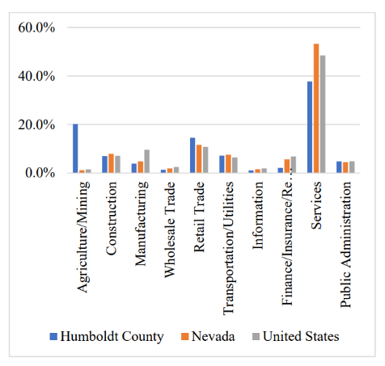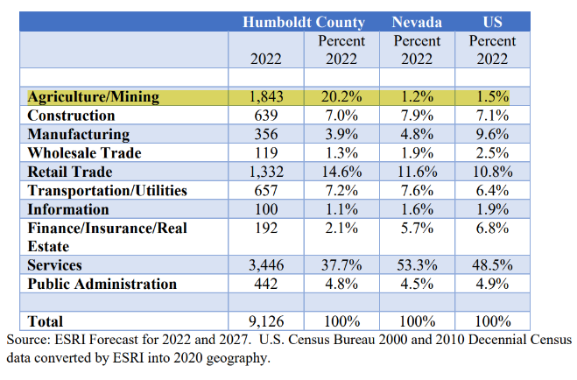

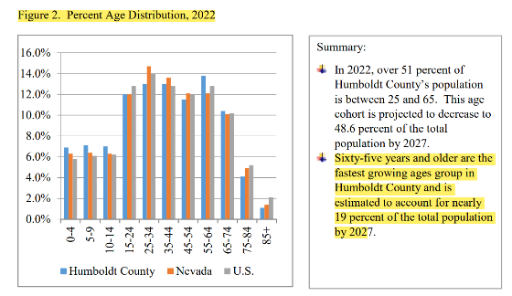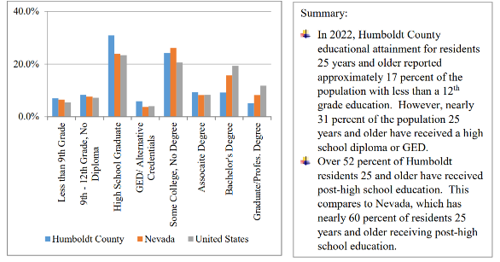

Reference：

Borden, Buddy, and Tom Harris. "Estimated Economic and Fiscal Impacts from New Lithium Mining and Processing Operations in Humboldt County, Nevada." (2023).

Analysis: The city could use more service industry instead of mine develop as there are more educated people.

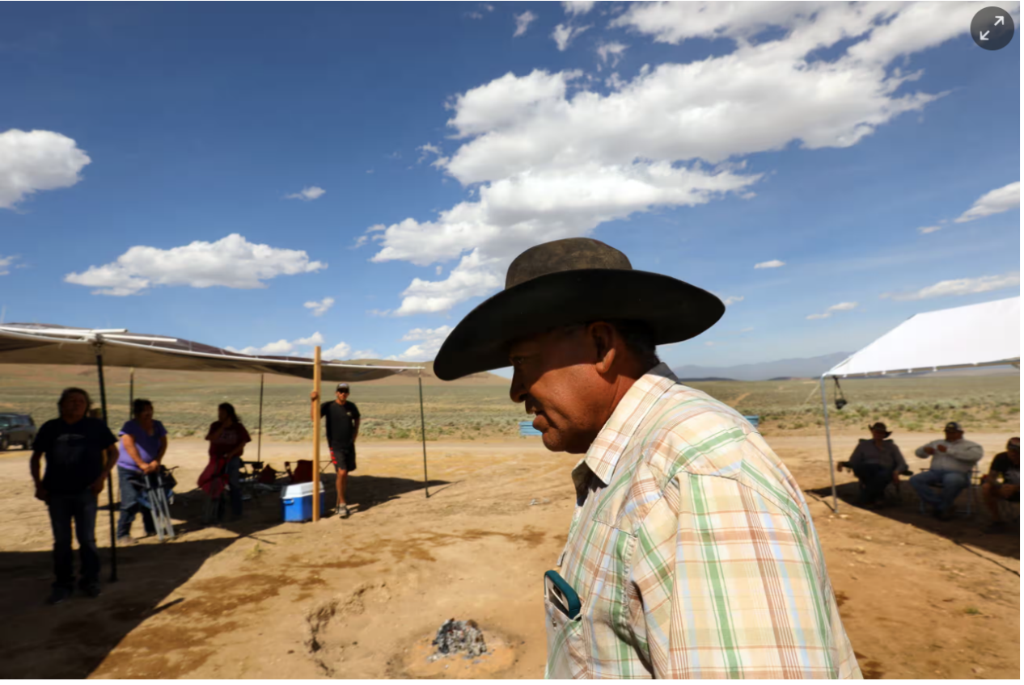

Myron Smart, leader of the Fort McDermitt Paiute Shoshone Tribe, speaks to tribal members and others who have gathered in opposition to the project. Photograph: Carolyn Cole/Los Angeles Times/Getty Images

**History exploitation of indigenous people**

The rugged and beautiful Thacker Pass in the desert mountains of northern [Nevada](https://www.theguardian.com/us-news/nevada) has long been a sacred site for Native American tribes in the region.

It has witnessed bloody and terrible history. On 12 September 1865, US federal soldiers in the 1st Nevada cavalry committed a massacre of Native Americans, the Numu, across Thacker Pass, [named](https://www.rsic.org/protect-thacker-pass-protect-peehee-muhuh/) Peehee Mu’huh – Rotten Moon, in the Numu language. Thirty to 50 Native Americans are believed to have been killed, including women and children.

Thacker Pass, located north of Winnemucca near the Oregon border, means Peehee mu’huh – “rotten moon” – in Paiute. According to indigenous oral history, Thacker Pass is the site of two Paiute massacres – one prior to colonization as part of an inter-tribal raid, and a second on Sept. 15, 1865, when federal troops massacred up to 50 Paiute in a surprise dawn attack.

Following archaeological exploration, evidence of a massacre has been confirmed by the Bureau of Land Management.

“We have to stand up – our people stood up here a long time ago,” said Dean Barlese, an elder with the Pyramid Lake Paiute Tribe.

The protestors were supported by members of Protect Thacker Pass, one of the groups opposing Lithium Nevada Corporation's project, which includes an open pit mine and removal of 17.2 million tons of rock and ore per year.

Production of a ton of lithium carbonate produces three times the emissions of producing a ton of steel on average, and uses a huge amount of water. The Thacker Pass lithium project is [expected](https://insideclimatenews.org/news/07112021/lithium-mining-thacker-pass-nevada-electric-vehicles-climate/) to use 1.7bn gallons of water annually to produce 60,000 metric tons of lithium carbonate a year.

A lawsuit [filed](https://www.rsic.org/thackerpass-newlawsuit/) by the Reno-Sparks Indian Colony and the Summer Lake Paiute Tribe is still pending in court against the project to recognize Thacker Pass as a cultural district. Another lawsuit filed by a rancher, four environmental groups, and two other Native American tribes was ruled in favor of the project and an appeal was [lost in July 2023](https://www.npr.org/2023/07/17/1188204958/tribes-object-federal-ruling-approves-lithium-mine).

Michon Eben, the tribal historic preservation officer for the Reno-Sparks Indian Colony, said she submitted the petition report to the Bureau of Land Management in February but has not heard any movement on it from the agency.

She said the regional office still has not turned it into the[National Park Service](https://www.nps.gov/subjects/nationalregister/faqs.htm)to review, respond, and put it on the national register. She also criticized the federal agency for not addressing these issues in the environmental impact statement for the mining project.

“That’s upsetting, because while they’re holding the report, the traditional cultural district has been destroyed. Because Lithium Americas is out there, they’re doing ground-disturbing activities in the area, which we state is a traditional cultural district,” said Eben. “So, if any tribes or anybody wanted to mitigate that destruction, what are we going to mitigate?”

Between 1864 to 1868, there were concerted efforts by the federal government to massacre Native Americans in the Great Basin area, a part of history not taught in schools and often ignored, Eben said.

“The world needs to know that an important historical event occurred there, and that the Bureau of Land Management is not following the National Historic Preservation Act, one of the federal laws that has to be followed during a project like this. They failed to conduct an ethnography with Paiute and Shoshone people,” added Eben.

[Around 85%](https://www.nature.com/articles/s41893-022-00994-6) of all lithium reserves are on or near indigenous land. In Argentina, indigenous communities held [demonstrations](https://www.lemonde.fr/en/environment/article/2023/08/01/lithium-at-the-heart-of-tensions-with-indigenous-communities-of-argentina_6075800_114.html) in June to oppose mining efforts, and met with riot police, resulting in numerous injuries of protesters. Lithium mining operations in Chile have [incited](https://www.nrdc.org/stories/lithium-mining-leaving-chiles-indigenous-communities-high-and-dry-literally) indigenous communities to decry the effects mining has had on water and farming practices.

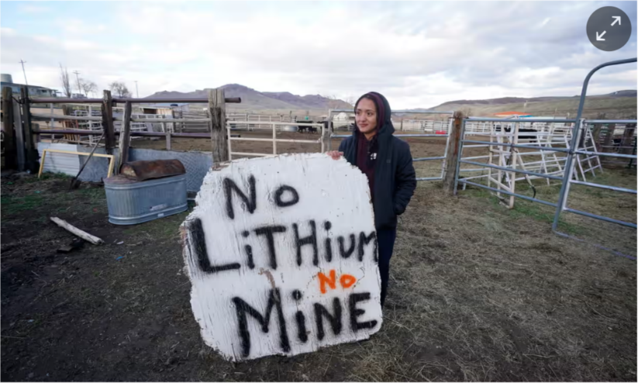

Daranda Hinkey holds a large hand-painted sign that says ‘No lithium, no mine’. Photograph: Rick Bowmer/AP

https://www.theguardian.com/us-news/2023/oct/13/native-americans-1865-massacre-lithium-mine-thacker-pass

ANLYSIS: The lithium mine is a genocide of the new age, it stops using guns and bullet to kill indigenous people and using finance invest and industrial pollution instead.

Sulfuric acid and sodium hydroxide used in lithium extraction penetrate the soil and water, poisoning ecosystems and endangering species. Research from the journal Proceedings of the Royal Society shows that two flamingo species in Chile are threatened because of lithium mining.

Refer: <https://www.mining-technology.com/analyst-comment/lithium-mining-negative-environmental-impact/>

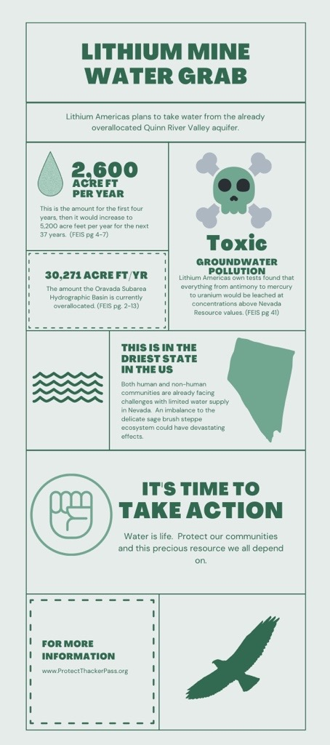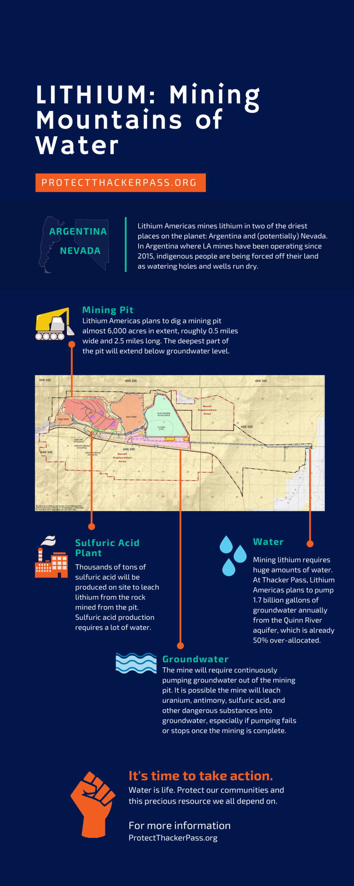

Reference link: <https://www.protectthackerpass.org/lithium-mining-mountains-of-water/>

The Northern Paiute never entered a formal agreement with the US federal government to cede their ancestral land rights, which encompasses Silver Peak. Silver Peak lithium extraction occurs on stolen Indigenous land. See: <https://www.bia.gov/as-ia/opa/online-press-release/legislation-required-settle-lon-standing-indian-claims>.

The Federal Government, three years earlier, had extended its authority without formal purchase over the territory of the "Western Shoshoni" and included within it the northern part of the lands occupied by the Northern Paiute tribes, assuming "the right of satisfying their claims by assigning them such reservations as might seem essential for their occupancy and supplying them in such degree as might seem proper with necessaries of life."

From 1864 to 1874 the President, by Executive Order, created several reservations to accommodate the Northern Paiute, including, in 1872, the Malheur Reservation for the Snake Indians. The lands were taken into possession by the Government "without formal relinquishment by the Indians," who did not, by any means, confine themselves to the reservations established for them.